



**Putting Your Feet First**

Fully qualified podiatrists

HCPC registered

Providing all aspects of foot care

Experienced specialists in diabetic foot care and the high-risk foot

Daytime, evening and weekend appointments available

Telephone and online booking available via our website



We have undergone Dementia Friends training

**145A Buxton Road, Stockport, SK2 6EQ**

**0161 480 5659**

[**fancyfeetstockport@yahoo.co.uk**](mailto:fancyfeetstockport@yahoo.co.uk)

****[**www.fancyfeetstockport.co.uk**](http://www.fancyfeetstockport.co.uk)



**Why visit a podiatrist?**

Our feet are often the most neglected part of our body. Usually, it is not until we experience discomfort or pain in our feet that we pay attention to them and realise how much we rely on them. This is where your podiatrist can help.

**About our podiatrists**

Our podiatrists have over 40 years combined experience working within the NHS and private practice.

They are experienced in treating a wide range of foot conditions and aim to ensure a relaxed, friendly environment whilst maintaining a professional, holistic approach at all times.

Our podiatrists are registered with the Health and Care Professions Council (HCPC) and members of the Royal College of Podiatry. They also undertake numerous hours of continued professional development training each year to ensure their knowledge and skills are kept up to date.

**Mrs Julie Gaskell, BSc(hons) RCPod**

[**HCPC: CH21973**](http://www.hpc-uk.org/search-results/search-details/?searchOption=1&search=gaskell&profession=CH&start=1&ID=21973)

Qualified from Salford University with a Bachelor of Science Honours Degree in Podiatry,

Qualified to administer Local Anaesthetics.

Certificate in Diabetes Care

Trained in Lacuna Method for treatment of fungal nails

Certified in first aid, basic life support, defibrillation and anaphylaxis training.

Julie has spent a proportion of her podiatry career working within the NHS in Stockport. She has developed a speciality in wound care, high-risk foot and diabetic foot care, gaining a wealth of knowledge and skills working within the high-risk foot team at Stepping Hill Hospital.

She practices all aspects of podiatry.

##### Mrs Natalie Gooding, BSc(hons) RCPod PGCert

##### [HCPC: CH29400](http://www.hpc-uk.org/search-results/search-details/?searchOption=1&search=mcmanamon&profession=CH&start=1&ID=29400)

##### Qualified from Salford University with a Bachelor of Science Honours Degree in Podiatry

PG Cert qualification in the Theory of Podiatric Surgery

Qualified to administer Local Anaesthetics

Certificate in Diabetes Care

Qualified and trained to carry out verruca needling.

Certified in first aid, basic life support, defibrillation and anaphylaxis training.

Natalie has spent a proportion of her podiatry career working within the NHS in both Sheffield and Stockport. She has developed a speciality in wound care, high risk and diabetic foot care, gaining a wealth of knowledge and skills working within the high-risk foot team at Stepping Hill Hospital.

She practices all aspects of podiatry.

Natalie is also the managing director of [The Organic Foot Company](http://www.theorganicfootcompany.co.uk/)

**Treatments we offer**

**A full visual foot check is carried out at every appointment as standard**

**General nail cutting**

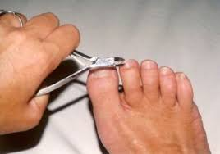

All toenails cut and filed and a luxury balm massaged into the feet.

(Fingernail cutting also available upon request for a small fee)

**Routine Podiatry**

All toenails cut and filed. All hard skin/ corns removed, followed by a luxury balm massaged into your feet.

**Deluxe Podiatry**

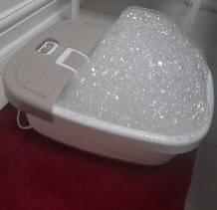

All toenails cut and filed. Hard skin/ corns removed. An exfoliating foot scrub will be used followed by a soak in a foot spa containing luxury natural products and a luxury balm massaged into your feet and cuticle oil applied to finish.

**Verruca treatments**

Debridement of any hard skin surrounding the verruca.

(see overleaf for more information)

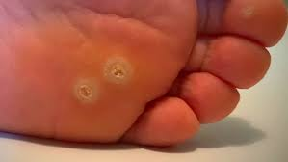

**In growing toenail surgery**

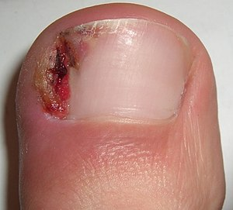

Full assessment required prior to procedure. The removal of severely damaged, problematic or ingrowing toenails under a local anaesthetic. For more information ask one of our friendly team.

**Verruca’s**



We offer various treatment options for verruca’s.

**Regular Debridement**. Hard skin can develop over a verruca and can cause discomfort. Removal of this hard skin can make the area more comfortable.

**Verrutop** is a zinc-nitric acid solution designed to gradually dry out the verruca.

It is applied by your podiatrist, recommended at 2-3 weekly intervals. Clinical studies show a clearance rate of around 40% with a single application and up to 90% after 6 applications.

It is virtually pain-free and it can be used in children as young as 6 years of age.

**Zinc oxide tape** is a tape impregnated with zinc oxide. Zinc oxide is a compound which has been used for many years in antiseptic creams as a healing agent. Studies have shown it is one of the best treatments for verruca’s in children. The enzymes in the tape help break down the verruca cells.

**Avoca Caustic Pencil 95% Silver Nitrate.** Recommended dose for verruca treatment is to apply once daily for 6 days following initial application by your podiatrist.

**Verruca needling** has been around for decades, but it is only now becoming a frequently used treatment in podiatry. In order to carry out this procedure, your podiatrist will have undertaken specific advanced training in this subject. Dry needling is a minor surgical procedure, performed under a local anaesthetic. Appointments generally take up to 1 hour. This allows for the anaesthetic to take effect and the verruca’s to be treated.

If you undergo the procedure, you will be reviewed again 1 week later. It will still take a number of weeks, sometimes months for verruca’s to resolve and in some circumstances it does not resolve the verruca’s at all. This treatment is only recommended for those over 18 who have tried all other treatments.

It is important to understand that there is no “quick fix” treatment for verruca’s.

Given time all verruca’s resolve on their own.

A full assessment must be undertaken by your podiatrist prior to starting any treatments for verruca’s.

**Warm wax therapy**

# **How It Works**

Warm wax is a common option in heat therapy treatments. Heat from the warm wax helps increase blood flow and relax muscles. This can help relieve discomfort caused by arthritis, fibromyalgia, sports and tendon injuries.

Warm wax can also increase hydration to help soften hardened/dry skin and increase skin elasticity.

It is not the same wax that beauty therapists use to remove hair.

**Conditions that benefit from therapeutic wax treatments:**

Chilblains  
Arthritis  
Bursitis  
Eczema and psoriasis  
Sore muscles  
Stiff joints  
Inflammation   
Muscle spasm  
Tendonitis  
Sports injury  
Scleroderma  
Poor circulation

# **What the treatment entails**

Your feet will be gently exfoliated, then submersed in a warm foot spa containing a vegan, natural ingredient foot soak and soaking salts (Himalayan Pink Salt, Dead Sea Salt, Epsom Salt blend) A lavender infused massage oil is then applied to both feet followed by the application of the wax.

We use single use, hygienic wax pods and a soft brush to apply the warm wax providing a luxurious & relaxing experience.  The wax is then left for around 10-15 minutes to work its magic then gently removed. A luxury foot balm will then be massaged into your feet and a cuticle oil applied to finish.

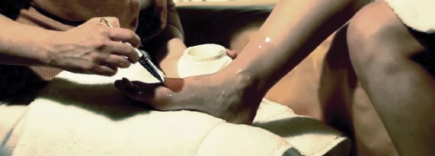

General Foot Health Advice

Good hygiene is essential for healthy feet. Wash and dry your feet thoroughly each day, especially in-between the toes. If you struggle to dry in between the toes, surgical spirit (a tiny amount wiped in between using a tissue or cotton bud) can help to dry this area.

Debris (dry skin, sock fluff etc.), can compact down the sides of the nails.

Whilst washing your feet, a toothbrush can be used to gently brush away debris. A separate toothbrush to the one you (or a family member) use on your teeth is recommended.

Apply small amounts of olive oil (using a cotton bud or similar) around the cuticles and nail edge. This will help to prevent a build-up of hard, dry skin down the sides. It will also help to hydrate dry nails/cuticles.

If cutting nails follow the natural contour of the nail. Filing nails gently using an emery board once or twice a week, will reduce the need to cut the nails as frequently. Do not cut your toenails too short or cut down the sides of the nails. This can result in painful, ingrown toenails.

Do not pick nails or the skin around them. This can create an entry for bacteria and risk infection.

Regular filing of any hard, dry skin using an emery board, is recommended to prevent it building up as quickly. We advise doing this when your skin is dry, before a bath/shower and before applying any cream. Filing skin when it is damp can result in too much skin being removed and make the skin sore.

Apply moisturising cream to the feet daily to prevent skin becoming dry and cracked. Do not apply cream in between the toes as this area can be moist already. If you struggle to reach your feet to apply cream, use an old flannel (or similar) to put cream on and then rub your feet on the flannel. We recommend putting socks on to ensure you do not slip after applying cream, or sit with the feet up long enough to let the cream absorb (5-10mins).

Rotate footwear regularly. We have approx. 250,000 sweat glands in our feet and perspire approx. ½ a pint of sweat a day from them. Rotating footwear gives shoes time to dry out and helps to prevent issues such as bacterial or fungal infections of the skin and nails.

Wear shoes that fit correctly. Shoes that are too tight or too loose can cause long term foot problems. Shop for shoes at the end of the day to compensate for foot swelling that may occur later in the day.

Avoid slip on shoes and shoes that are wide and deep enough to allow ‘wiggle room’ for the toes in the front of the shoe. It is advised to have around 1-2cm room from the top of your longest toe to the top of your shoe.

Check your feet daily for any changes to skin colour, cuts, cracks to the skin, or problems with your nails not previously noticed.

**REMEMBER foot pain or discomfort is not normal. If you have any concerns, please seek help and advice from your podiatrist.**